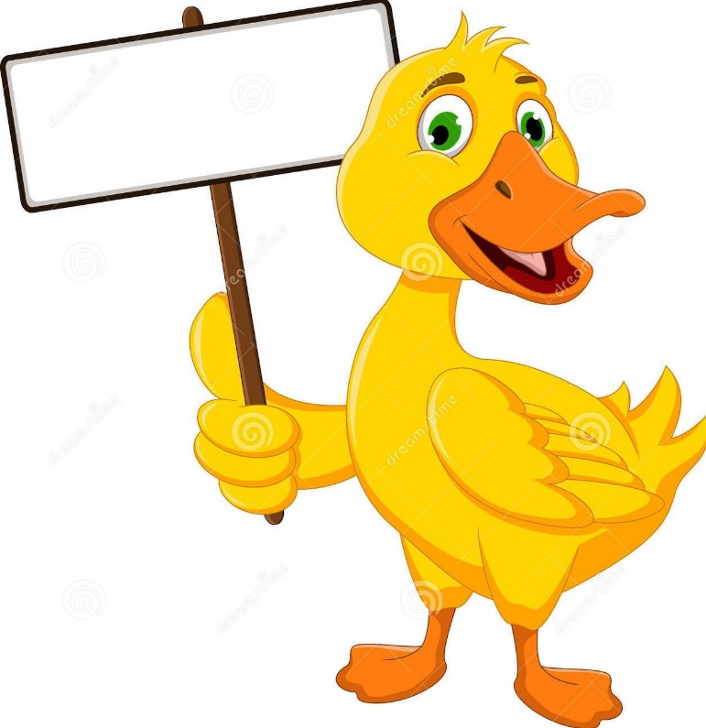
BACK THE QUACK

ADOPT A DUCK
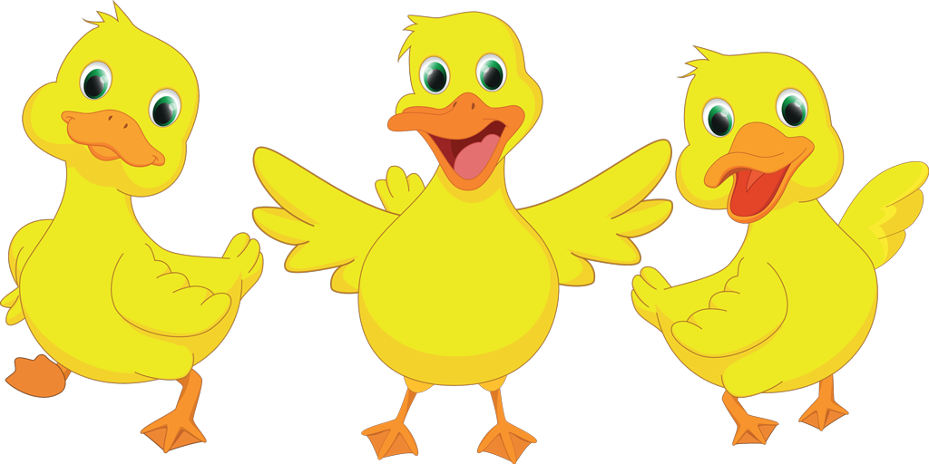

Sponsored by the
MONSON LIONS CLUB

Race to be held at the
MONSON FOOD TRUCK FESTIVAL
4PM
September 24, 2022
PRIZES
FIRST PLACE------------------$300.
SECOND PLACE--------------$200.
THIRD PLACE-----------------$100.

ONLY 500 DUCKS
WILL BE SOLD

You need not be present to win

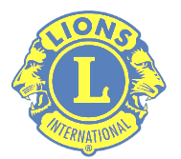

THANK YOU FOR YOUR SUPPORT
LEARN MORE ABOUT
MONSON LIONS CLUB
monsonlionsclub.org

DUCK ADOPTION FORM
I hereby register for adoption
and entry into
THE LUCKY DUCK RACE,
THE FOLLOWING DUCK(S)
NAME OF DUCK(S):
- ______________________________________
- ______________________________________
- ______________________________________
- ______________________________________
- ______________________________________
- ______________________________________
- ______________________________________
- ______________________________________
- ______________________________________
- ______________________________________
ADOPTION FEE $5.00 PER DUCK
ADOPTER’S
NAME_________________________________
______________________________________
ADDRESS______________________________________________________________________
_______________________________________
PHONE_________________________________
PLEASE SUBMIT FORM WITH PAYMENT TO:
MONSON LIONS CLUB
PO BOX 142
MONSON, MA 01057

