IS JUVENILE DIABETES KEEPING YOUR CHILD FROM
THE COMMON CHILDHOOD EXPERIENCES OF
SUMMER CAMP?
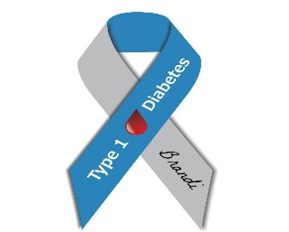
This Photo by Unknown Author is licensed under CC BY-ND
Thomas Day Spring Lodge
The Monson Lions Club

We are partnering together to make a one-week Resident Summer Camp experience available to an insulin-dependent child from Monson, MA

Barton Center for Diabetes Education, Inc offers camping for insulin dependent children ages 6-16 at:
Clara Barton Camp for girls, located in Oxford, MA
Camp Joslin for boys, located in Charlton, MA
for information about the facilities visit
bartoncenter.org
Barton Center Mission
“To improve the lives of children with insulin-dependent diabetes through education, recreation, and support programs which inspire and empower”
To apply for this 2023 one-week Campership contact:
application must be submitted by Dec 31,2022
Monson Lions Club
monsonlionsclub@gmail.com
413-893-6401
Thomas Day Spring Lodge
Thomas.dayspring.lodge@gmail.com
413-277-5702
or

